

Wallet Walkthrough – Hands-on Wallet Setup   
  
**Objective/Aim:**



To learn how to create and use a cryptocurrency wallet, understand the importance of private keys,

public addresses, and safely manage digital assets.

**Apparatus/Software Used:**

Laptop/PC or Mobile Phone

MetaMask Wallet

Browser Extension or Mobile App

Internet connection

**Theory/Concept:**

* **Crypto Wallet:**  
   A digital tool to store, send, and receive cryptocurrency.
* **Private Key:**  
   A secret key that proves ownership of funds. Must be kept confidential at all times.
* **Public Address:**  
   A wallet’s unique identifier, used to receive cryptocurrency.
* **Seed Phrase (Recovery Phrase)**:  
   A set of 12 (or 24) words generated when creating a wallet. It is the backup to restore funds in case of device loss.



**Procedure:**

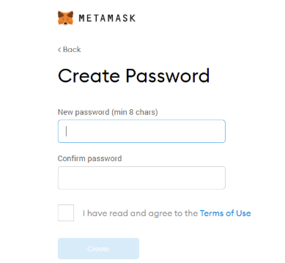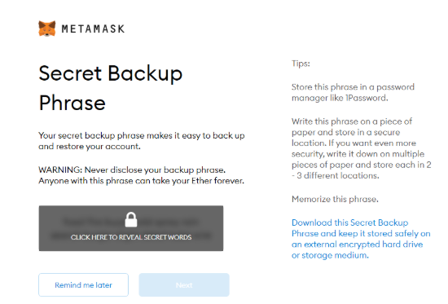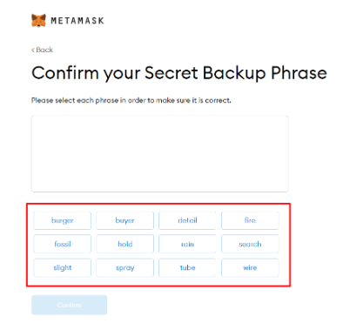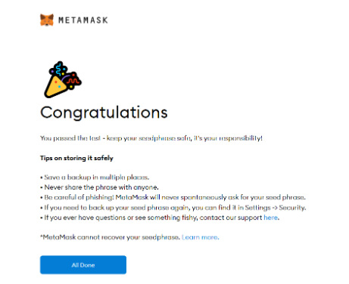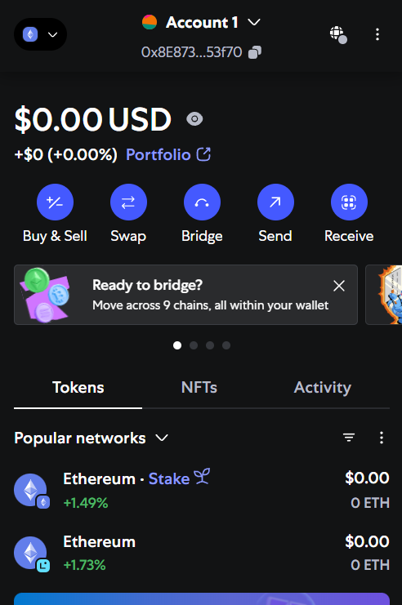

* Install metamask browser extension.
* Click Create a New Wallet.
* Securely write down the Seed Phrase and store it safely.
* After setup, access the public address to receive crypto.

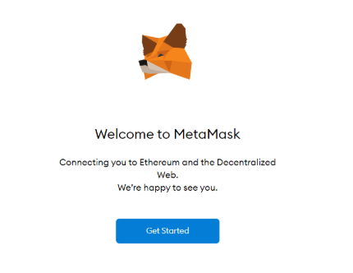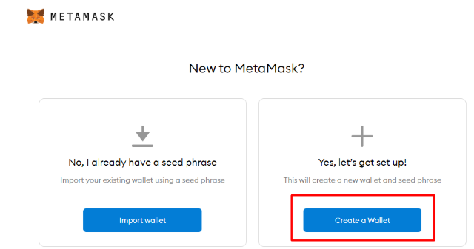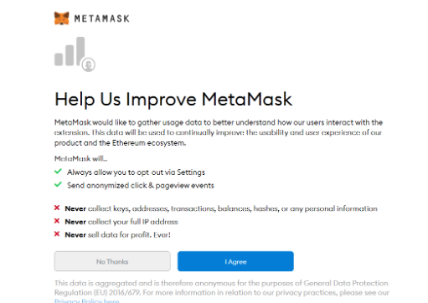

**Observation :-**

MetaMask wallet installed successfully.

New wallet created with a secure password.

12-word seed phrase generated and saved safely.

Private key do not share with anyone

Unique public address assigned.

Transaction visible on blockchain explorer.

AAA



|  |  |  |  |
| --- | --- | --- | --- |
|  |  |  |  |
|  |  | nbvnvnvx |  |
|  |  |  |  |
|  |  |  |  |
|  |  |  |  |
|  |  |  |  |
|  |  |  |  |